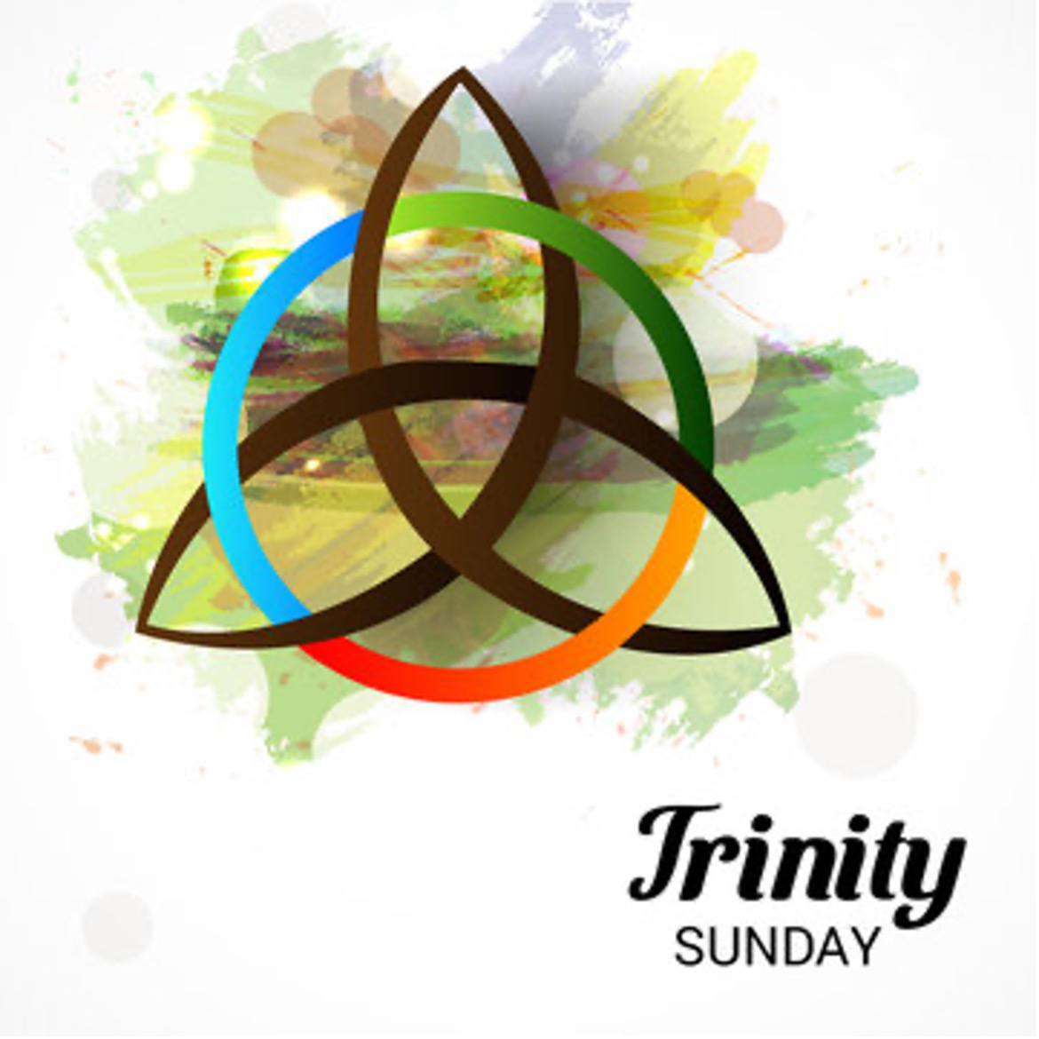

Trinity Sunday, Year A
4 June 2023

PRELUDE MUSIC Hank Curtis

I Want to Be Ready I Bind Unto Myself Today
African-American Spiritual Irish Melody, “St. Patrick’s Breastplate”

Holy God We Praise Thy Name The Spacious Firmament on High
17th-Century German Tune “Grosse Gott” Franz Joseph Haydn

Many and Great, O God, Are Thy Works Thy Strong Word Did Cleave the Darkness
Dakota Indian Chant Thomas John Williams

PRELUDE MEDITATION

Glory to God in the Highest
Frank E. White

PROCESSIONAL

I Sing the-Almighty Power of God Blue Hymnal 398
Music: “Forest Green,” English Melody; Harm.: Ralph Vaughan Williams
Words: Isaac Watts

- I sing the-almighty power of God, that made the mountains rise,
that spread the flowing seas abroad and built the lofty skies.
I sing the wisdom that ordained the sun to rule the day;
the moon shines full at his command, and all the stars obey.

- I sing the goodness of the Lord, that filled the earth with food;
he formed the creatures with his word, and then pronounced them good. Lord, how thy wonders are displayed, where’er I turn my eye,
if I survey the ground I tread, or gaze upon the sky!

- There’s not a plant or flower below, but makes thy glories known;
and clouds arise and tempests blow, by order from thy throne.
While all that borrows life from thee is ever in thy care,
and everywhere that I could be, thou, God, art present there.

OPENING ACCLAMATION

Pōmaikaʻi ke Akua: Ka Makua, ke Keiki, a me ka ʻUhane Hemolele.
Blessed be God: Father, Son, and Holy Spirit.
And blessed be God’s kingdom, now and for ever. Amen.

COLLECT FOR PURITY

Almighty God, to you all hearts are open, all desires known, and from you no secrets are hid. Cleanse the thoughts of our hearts by the inspiration of your Holy Spirit, that we may perfectly love you, and worthily magnify your holy Name; through Christ our Lord. Amen.

GLORIA Blue Hymnal S-280

Glory to God in the highest, and peace to his people on earth.
Lord God, heavenly King, almighty God and Father,
we worship you, we give you thanks, we praise you for your glory.

Lord Jesus Christ, only Son of the Father, Lord God, Lamb of God,
you take away the sin of the world; have mercy on us;
you are seated at the right hand of the Father; receive our prayer.

For you alone are the Holy One, you alone are the Lord,
you alone are the Most High, Jesus Christ, with the Holy Spirit,
in the glory of God the Father. Amen.

COLLECT OF THE DAY

E noho pū ka Haku me ʻoukou. The Lord be with you.
And also with you.
E pule kākou. Let us pray.
Almighty and everlasting God, you have given to us your servants grace, by the confession of a true faith, to acknowledge the glory of the eternal Trinity, and in the power of your divine Majesty to worship the Unity: Keep us steadfast in this faith and worship, and bring us at last to see you in your one and eternal glory, O Father; who with the Son and the Holy Spirit live and reign, one God, for ever and ever. Amen.

FIRST READING Genesis 1:1-2, 24-2:4a

At the beginning of time, God the Creator, God the powerful Word, and God the life-giving Spirit form the earth and all its inhabitants. God sees that all this created work is good and then rests on the seventh day.

A reading from Genesis.

When God began to create the heavens and the earth— the earth was without shape or form, it was dark over the deep sea, and God’s wind swept over the waters.

After the first five days of creating the waters and sky, the lights distinguishing day and night, and the earth, as well as all living things inhabiting these areas, God said, “Let the earth produce every kind of living thing: livestock, crawling things, and wildlife.” And that’s what happened. God made every kind of wildlife, every kind of livestock, and every kind of creature that crawls on the ground. God saw how good it was.

Then God said, “Let us make humanity in our image to resemble us so that they may take charge of the fish of the sea, the birds in the sky, the livestock, all the earth, and all the crawling things on earth.” God created humanity in God’s own image, in the divine image God created them, female and male God created them.

God blessed them and said to them, “Be fertile and multiply; fill the earth and master it. Take charge of the fish of the sea, the birds in the sky, and everything crawling on the ground.” Then God said, “I now give to you all the plants on the earth that yield seeds and all the trees whose fruit produces its seeds within it. These will be your food. To all wildlife, to all the birds in the sky, and to everything crawling on the ground—to everything that breathes—I give all the green grasses for food.” And that’s what happened. God saw everything God had made: it was supremely good. There was evening and there was morning: the sixth day.

The heavens and the earth and all who live in them were completed. On the sixth day God completed all the work that God had done, and on the seventh day God rested from all the work that God had done. God blessed the seventh day and made it holy, because on it God rested from all the work of creation. This is the account of the heavens and the earth when they were created.

The Word of the Lord.
Thanks be to God.

SECOND READING 2 Corinthians 13:11-13

Paul closes a challenging letter to the Corinthians with an appeal to Christian fellowship grounded in the triune harmony of Christ’s grace, God’s love, and the Spirit’s partnership.

A reading from Second Corinthians.
Finally, my siblings, farewell. Put all things in order, listen to my appeal, agree with one another, live in peace; and the God of love and peace will be with you. Greet one another with a holy kiss. All the saints greet you.
The grace of the Lord Jesus Christ, the love of God, and the communion of the Holy Spirit be with all of you.
The Word of the Lord.
Thanks be to God.

THE GOSPEL Matthew 28:16-20

Ka ʻEuanelio hemolele o ko kākou Haku, ʻo Iesu Kristo ma Mataio.
The Holy Gospel of our Lord Jesus Christ, according to Matthew.
Glory to you, Lord Christ.

The eleven disciples went to Galilee, to the mountain to which Jesus had directed them. When they saw him, they worshiped him; but some doubted. And Jesus came and said to them, “All authority in heaven and on earth has been given to me. Go therefore and make disciples of all nations, baptizing them in the name of the Father and of the Son and of the Holy Spirit, and teaching them to obey everything that I have commanded you. And remember, I am with you always, to the end of the age.”

Ka ʻEuanelio o ka Haku. The Gospel of the Lord.
Praise to you, Lord Christ.

THE SERMON The Trinity: God’s Dream in Practice Kahu Kawika Jackson

MUSICAL RESPONSE Hank Curtis

Immortal, Invisible, God Only Wise
19th-Century Welsh Tune, “St. Denio”

THE PRAYERS OF THE PEOPLE

With all our heart and with all our mind, let us pray to the Lord, saying, “E ka Haku, e aloha mai” (“Lord, have mercy”) (A brief silence.)

For the unity of all people, that there may there be a growing spirit of respect and forbearance among communities and nations; for the peace of belonging to your ʻohana; and for your loving-kindness for the salvation of our souls. We pray to you, O Lord.
E ka Haku, e aloha mai.

For the welfare of the Holy Church of God worldwide, especially for the clergy and people of the Episcopal/Anglican Province of Alexandria; and for the Chaplains at our Episcopal Schools: The Rev. Heather Patton-Graham (the St. Andrew’s Schools Chapel); The Rev. Tim Morehouse & the Rev. Andrew Arakawa (ʻIolani School); and the Rev. Christopher Golding (Seabury Hall). We pray to you, O Lord.
E ka Haku, e aloha mai.

For Michael, our Presiding Bishop; for Bob, our own Bishop; for Kawika, our Priest; for our sibling Episcopal congregations on Kauaʻi: St. John and St. Paul, West Kauaʻi; St. Michael & All Angels, Līhuʻe; and Christ Memorial, Kilauea; and our own congregation of All Saints – those present, online, and absent – that all of us together may be united in your ministry and that we all may be one. We pray to you, O Lord.
E ka Haku, e aloha mai.

For the good earth graciously given by our Creator; for the care of our global environment; and for the wisdom and will to conserve it for your glory and for the blessing of all. We pray to you, O Lord.
E ka Haku, e aloha mai.

For those in positions of public trust, that they may deal justly and promote the dignity and freedom of every person, that your wisdom and compassion may govern their decisions, priorities, and actions. We pray against the use of violence of any kind, and ask that your healing balm of peace and mutual respect would hold sway in our land. We pray to you, O Lord.
E ka Haku, e aloha mai.

For the sick and suffering in body, mind, and spirit, we pray for: Peace in Ukraine; Presiding Bishop Michael Curry; Terry; Seowon Park; Melissa & Alexis; Tan Popatas; and those we name silently or aloud. (Brief silence) We pray to you, O Lord.
E ka Haku, e aloha mai.

God of new life, as you raised Jesus from the dead, so raise up those who have died in you. We commend to your loving care those we name silently or aloud. (Brief silence) We thank you for their example and rejoice in their lives. We pray to you, O Lord.
E ka Haku, e aloha mai.

Rejoicing in the fellowship of the ever-blessed Virgin Mary and St. Joseph, King Kamehameha IV and Queen Emma, Queen Lili‘uokalani and all the saints, let us commend ourselves, and one another, and all our life to Christ our God.
Ho‘omaika‘i iā e ka Haku. (Praise to you, O Lord.)

THE QUEEN’S PRAYER Queen Lili‘uokalani

- ‘O kou aloha nō, Aia i ka lani,
A ‘o kou ‘oiaʻiʻo, he hemolele hoʻi.
(Your love is in Heaven, and your Truth – so perfect.)

- Koʻu noho mihi ‘ana, A paʻahao ‘ia,
‘O ‘oe kuʻu lama, kou nani koʻu koʻo.
(I live in sorrow, imprisoned; you are my light, my support.)

- Mai nana ‘inoʻino, Na hewa o kanaka,
Aka, e huikala, A maʻemaʻe no.
(Behold not with malevolence human sins, but forgive and cleanse.)

- No laila e ka haku, Ma lalo kou ‘eheu
Ko makou maluhia, A mauloa aku no. ‘Āmene.
(And so, O Lord, beneath your wings be our peace forevermore. Amen.)

THE PEACE

The Peace of the Lord be always with you.
And also with you.

ANNOUNCEMENTS

OFFERTORY ANTHEM

All Things Bright and Beautiful Blue Hymnal 405
Music: “Royal Oak,” Melody from The Dancing Master
Words: Cecil Frances Alexander

(Refrain) All things bright and beautiful, all creatures great and small, all things wise and wonderful, the Lord God made them all.

- Each little flower that opens, each little bird that sings,
he made their glowing colors, he made their tiny wings. (Refrain)

- The purpleheaded mountain, the river running by,
the sunset, and the morning that brightens up the sky. (Refrain)

- The cold wind in the winter, the pleasant summer sun,
the ripe fruits in the garden, he made them every one. (Refrain)

- He gave us eyes to see them, and lips that we might tell
how great is God Almighty, who has made all things well. (Refrain)

HAWAIIAN DOXOLOGY

Ho‘onani i ka Makua mau,
Ke Keiki me ka ‘Uhane nō,
Ke Akua mau ho‘omaika‘i pū,
Ko kēia ao, ko kēlā ao.
‘Āmene.

THE LITURGY OF THE SACRAMENT

The Lord be with you.
And also with you.
Lift up your hearts.
We lift them to the Lord.
Let us give thanks to the Lord our God.
It is right to give God thanks and praise.
It is truly right, and good and joyful, to give you thanks, all-holy God, source of life and fountain of mercy. You have filled us and all creation with your blessing and fed us with your constant love; you have redeemed us in Jesus Christ and knit us into one body.
Through your Spirit you replenish us and call us to fullness of life. Therefore, joining with Angels and Archangels and with the faithful of every generation,
we lift our voices with all creation as we say/sing:

SANCTUS BLUE HYMNAL S-129

Holy, holy, holy, Lord, God of power and might:
Heaven and earth are full of your glory.
Hosanna in the highest!
Blessed is He who comes in the name of the Lord.
Hosanna in the highest!
Blessed are you, gracious God, creator of the universe and giver of life. You formed us in your own image and called us to dwell in your infinite love. You gave the world into our care, that we might be your faithful stewards and show forth your bountiful grace.
But we failed to honor your image in one another and in ourselves; we would not see your goodness in the world around us; and so we violated your creation, abused one another, and rejected your love. Yet you never ceased to care for us, and prepared the way of salvation for all people.
Through Abraham and Sarah you called us into covenant with you. You delivered us from slavery, sustained us in the wilderness, and raised up prophets to renew your promise of salvation. Then, in the fullness of time,
you sent your eternal Word, made mortal flesh in Jesus. Born into the human family, and dwelling among us, he revealed your glory. Giving himself freely to death on the cross, he triumphed over evil, opening the way of freedom and life.
On the night before he died for us, our Savior Jesus Christ took bread,
and when he had given thanks to you, he broke it, and gave it to his friends, and said: “Take, eat: This is my Body which is given for you. Do this for the remembrance of me.”
As supper was ending, Jesus took the cup of wine, and when he had given thanks, he gave it to them, and said: “Drink this, all of you: This is my Blood of the new Covenant, which is poured out for you and for all for the forgiveness of sins. Whenever you drink it, do this for the remembrance of me.”
Therefore we proclaim the mystery of faith:
Christ has died.
Christ is risen.
Christ will come again.
Remembering his death and resurrection, we now present to you from your creation this bread and this wine. By your Holy Spirit may they be for us
the Body and Blood of our Savior Jesus Christ. Grant that we who share these gifts may be filled with the Holy Spirit and live as Christ’s Body in the world.
Bring us into the everlasting heritage of your daughters and sons,
that with Queen Emma and King Kamehameha IV, Queen Liliʻuokalani, all your saints, past, present, and yet to come, we may praise your Name for ever.
Through Christ and with Christ and in Christ, in the unity of the Holy Spirit,
to you be honor, glory, and praise, for ever and ever. Amen.
And now, as our Savior Christ has taught us, we are bold to say:

Our Father, who art in heaven, hallowed be thy Name,
thy kingdom come, thy will be done, on earth as it is in heaven.
Give us this day our daily bread.
And forgive us our trespasses, as we forgive those who trespass against us.
And lead us not into temptation, but deliver us from evil.
For thine is the kingdom, and the power, and the glory,
for ever and ever. Amen.
God of promise, you have prepared a banquet for us. Happy are those who are called to the Supper of the Lamb!
The gifts of God, for the people of God. Take them in remembrance that Christ died for you, and feed on him in your hearts by faith, with thanksgiving.

COMMUNION MUSIC

God the Sculptor of the Mountains O Threefold God of Tender Mercy
Sarum Plainchant Tune, “Urbs Beata” Carl Flengte Schalk

POST-COMMUNION PRAYER
Loving God, we give you thanks for restoring us in your image
and nourishing us with spiritual food
in the Sacrament of Christ’s Body and Blood.
Now send us forth: a people forgiven, healed, renewed;
that we may proclaim your love to the world
and continue in the risen life of Christ our Savior. Amen.

BLESSING

Ka hoʻopōmaikaʻi ʻana o ke Akua mana loa – ka Makua, ke Keiki, a me ka ʻUhane – me ʻoukou a e noho pū me ʻoukou a mau loa aku. ʻĀmene.

The blessing of God Almighty – the Source, the Son, and the Spirit – be upon you and remain with you for ever. Amen.

RECESSIONAL

Holy, Holy, Holy! Lord God Almighty! Blue Hymnal 362
Music: “Nicaea,” John Bacchus Dykes
Words: Reginald Heber

- Holy, holy, holy! Lord God Almighty!
Early in the morning our song shall rise to thee:
Holy, holy, holy! Merciful and mighty,
God in three Persons, blessed Trinity.

- Holy, holy, holy! All the saints adore thee,
casting down their golden crowns around the glassy sea;
cherubim and seraphim falling down before thee,
which wert, and art, and evermore shall be.

- Holy, holy, holy! Though the darkness hide thee,
though the sinful human eye thy glory may not see,
only thou art holy; there is none beside thee,
perfect in power, in love, and purity.

- Holy, holy, holy! Lord God Almighty!
All thy works shall praise thy Name, in earth, and sky, and sea.
Holy, holy, holy! Merciful and mighty,
God in three Person, blessed Trinity.

DISMISSAL

E hele aku ʻoukou me ka maluhia e aloha a e mālama i ke Akua: Aleluia, aleluia!
Go in peace, to love and serve our God: Alleluia, alleluia!
Thanks be to God. Alleluia, Alleluia! Alleluia!

POSTLUDE

New World Turning
David Lanz

